Pass Task 3 - Spells

# Related Learning Outcomes

# ULO1 – Explain the OO Principles

This exercise demonstrated using enumeration to declare a new type and reference it in a objects class.

# ULO2 – Use OO Language and Library

Demonstrated class and constructor declaration, the use of conditional statements (e.g. “if”), and assigning values to parameters. The task examines how fields can be used by an object to remember information. We used a Property to get the name and value from the counter and be able to access it outside the object.

# ULO3 – Design, Develop and Test using an IDE

The code was developed using Xamarin Studio to build and run the program, as well as integrated debugging features to step and inspect values.

# ULO4 – Communicate using UML Diagrams

I learned how to interpret a UML class diagram and write the related code.

Shows the relationship between the 2 documents spell Kind and Spell.

# ULO5 – Describe Elements of Good OO Design

The exercise demonstrated correct use of C# coding conventions.

# Screenshots

[code running]

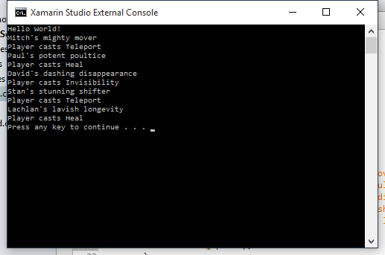

[use of IDE]

